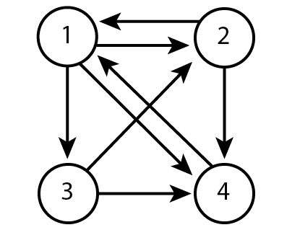
Network A
Start at any location in the network above and move following the paths as indicated. At each iteration, “flip a coin” to decide which path to take. For example, if you start at 1, there are three choices to take, you can roll a die and if it is 1 or 2, you move to 2, if it is 3 or 4, you would move to 3 and 5 or 6, then you can move to 4. Use this random moving scheme and perform 20 iterations. Please record the number of times you visit each node.

Starting Node :
# of visits
Node 1
Node 2
Node 3
Node 4
Total Iterations

Starting Node :
# of visits
Node 1
Node 2
Node 3
Node 4
Total Iterations

Starting Node :
# of visits
Node 1
Node 2
Node 3
Node 4
Total Iterations

Starting Node :
# of visits
Node 1
Node 2
Node 3
Node 4
Total Iterations

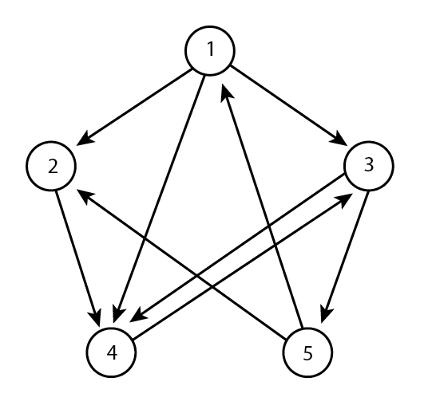
Network B
Start at any location in the network above and move following the paths as indicated. At each iteration, “flip a coin” to decide which path to take. For example, if you start at 1, there are three choices to take, you can roll a die and if it is 1 or 2, you move to 2, if it is 3 or 4, you would move to 3 and 5 or 6, then you can move to 4. Use this random moving scheme and perform 20 iterations. Please record the number of times you visit each node.

Starting Node :
# of visits
Node 1
Node 2
Node 3
Node 4
Node 5
Total Iterations

Starting Node :
# of visits
Node 1
Node 2
Node 3
Node 4
Node 5
Total Iterations

Determining Importance:
- Based on the number of visits to each node in the network, which node would you say is the most important?

- Using Network A, can you count how many ways you can start and end at node 3 in 3 iterations?

- Still using A, count how many ways once can start at node 4 and be at node 2 in 4 interations

- Using Network B, can you count how many ways you can start at node 3 and end at node 4 after 3 iterations?

- Using Network B, can you count how many ways you can start at node 1 and end at node 5 after 3 iterations?

- How can you begin to model mathematically, i.e., count the number of times you would visit each node of a network? Describe in words

